**NutriBuddy User Guide**

**Argos Inc**

RoeMello Holliday, Austin Killough, Chandler Neece, Chavis Sanchez

**Team Leader:** Austin Killough

Capstone Project Spring 2024

The University of West Florida

April 26, 2024

CIS4595 Capstone

Dr. OK

# **Table of Contents**

**Table of Contents 2**

**Product Features 3**

**Product Functions and Capabilities 3**

**Walkthrough 3**

**Installation Instructions 7**

**FAQ 10**

**Troubleshooting 10**

# **Product Features**

Five primary features are available for the user upon this version of the application:

1. User Authentication
2. Track Daily Caloric Intake
3. Access Nutritional Information
4. Log Food
5. Interact with AI Chatbot

# **Product Functions and Capabilities**

The product functions essentially as a typical nutritional tracker. However, it’s capabilities extend beyond this towards a conversational in-app AI that can discuss nutritional information. This extends functionality from a rigid calorie tracker to an informational learning tool for nutritional and fitness information.

# **Walkthrough**

Begin by following the link provided in the terminal. This will take the user to the home page where they can click the “Get Started” button to create an account.

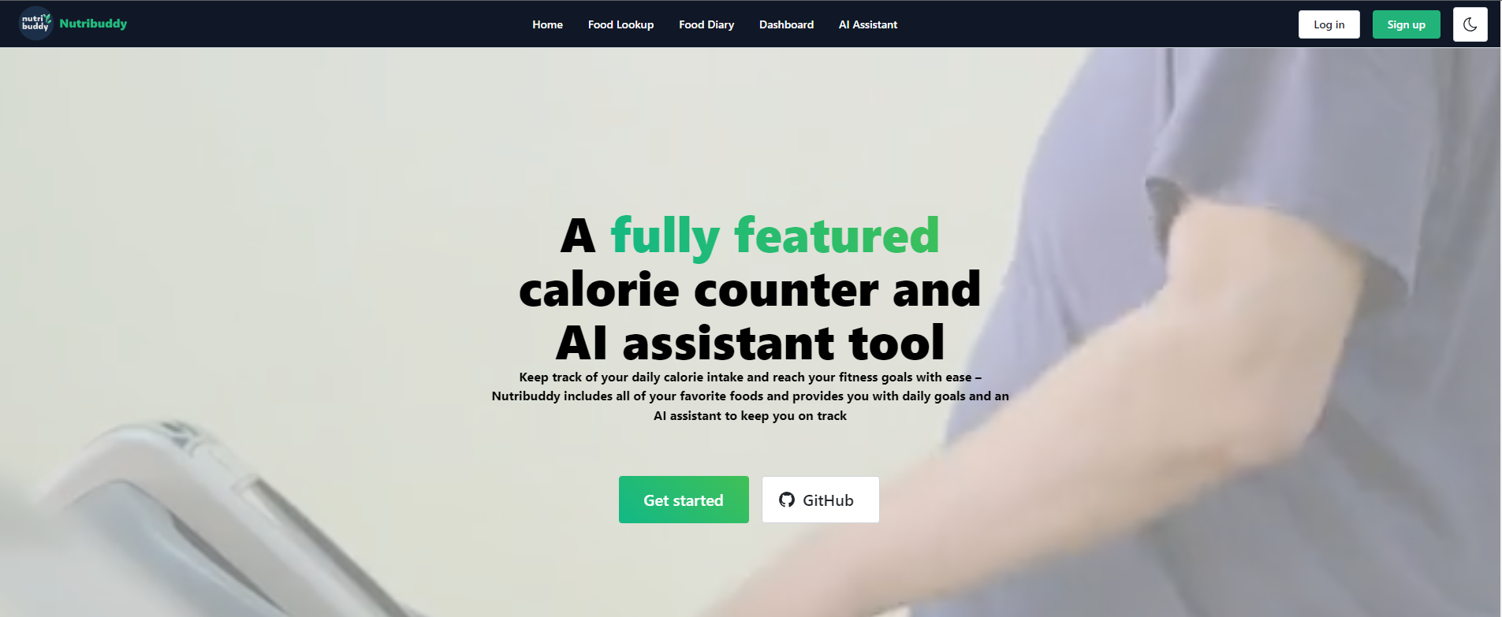

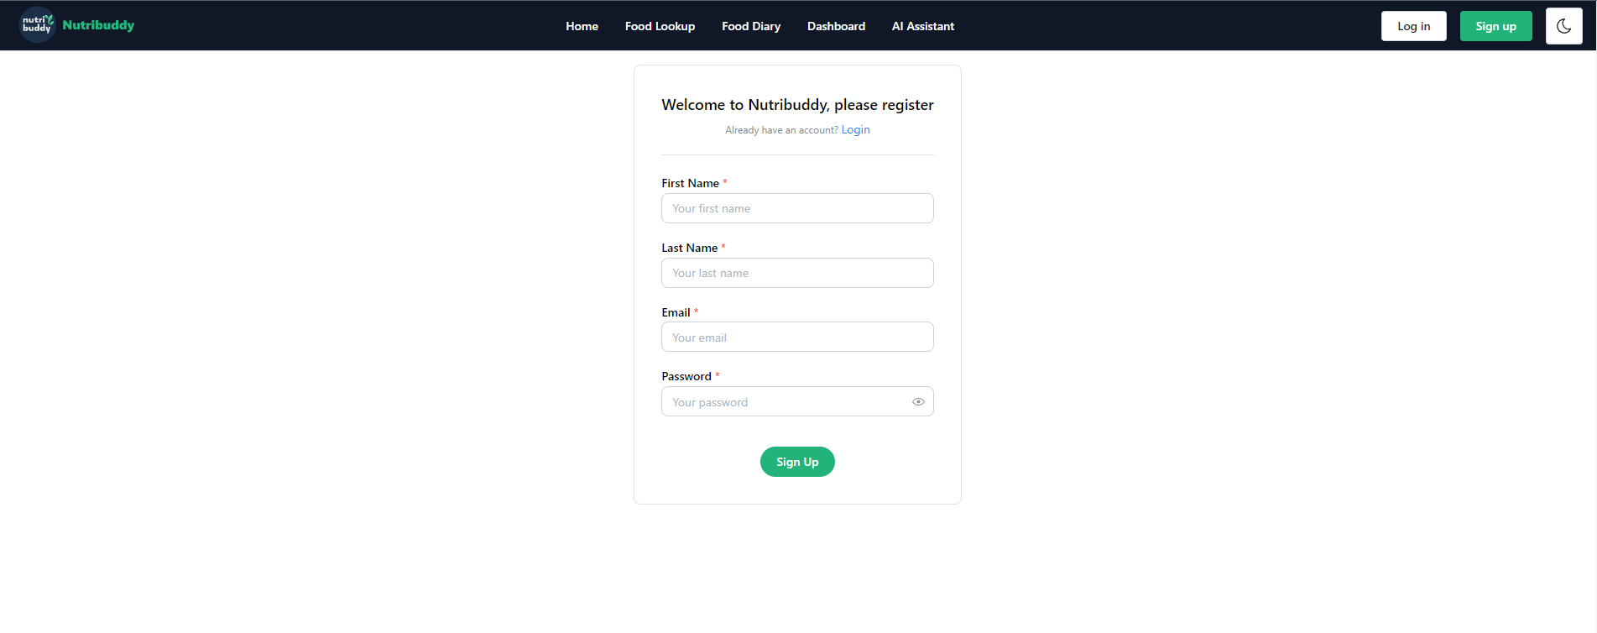

The user will need to create an account to use the application’s features.

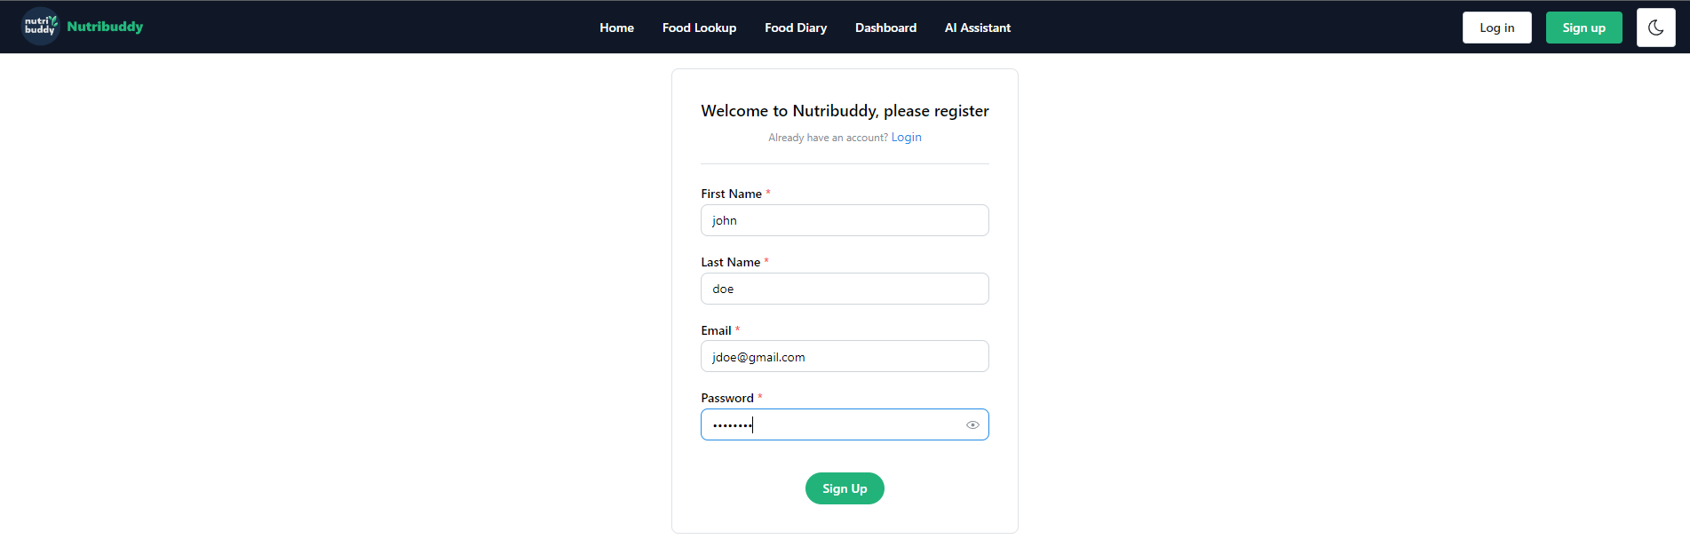

Once the account is created the user will be taken to the login page where they can log into their account. Once logged in they will be prompted to enter some health information to set up their account.



Once this information is filled out the account is set up and the user will be able to use the application’s features.

Once all the information is set up, the application can be navigated using the top menu.

**Home/Food Diary Page**

On the home page the user is presented with their Food Diary which provides the food they have consumed for the selected day and the total calories consumed. Specific dates can be selected to see past meals.

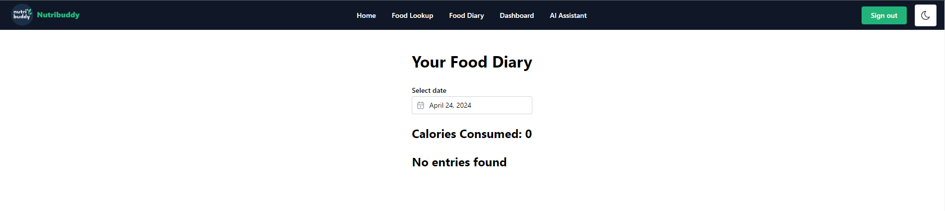

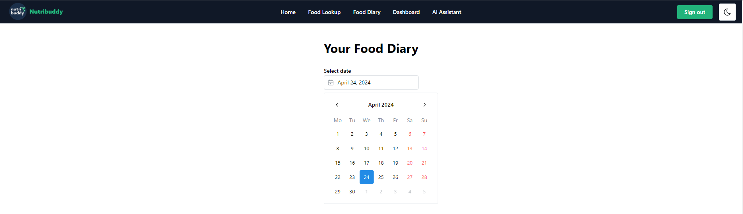

**Food Lookup Page**

On the Food Lookup page the user can look up food to add them to their daily meals. The lookup works by typing in a food into the search bar and hitting submit.

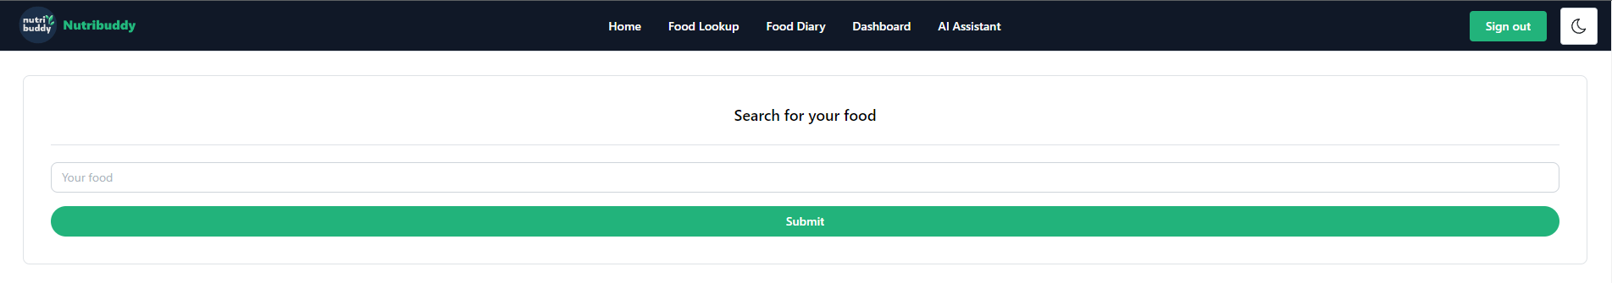

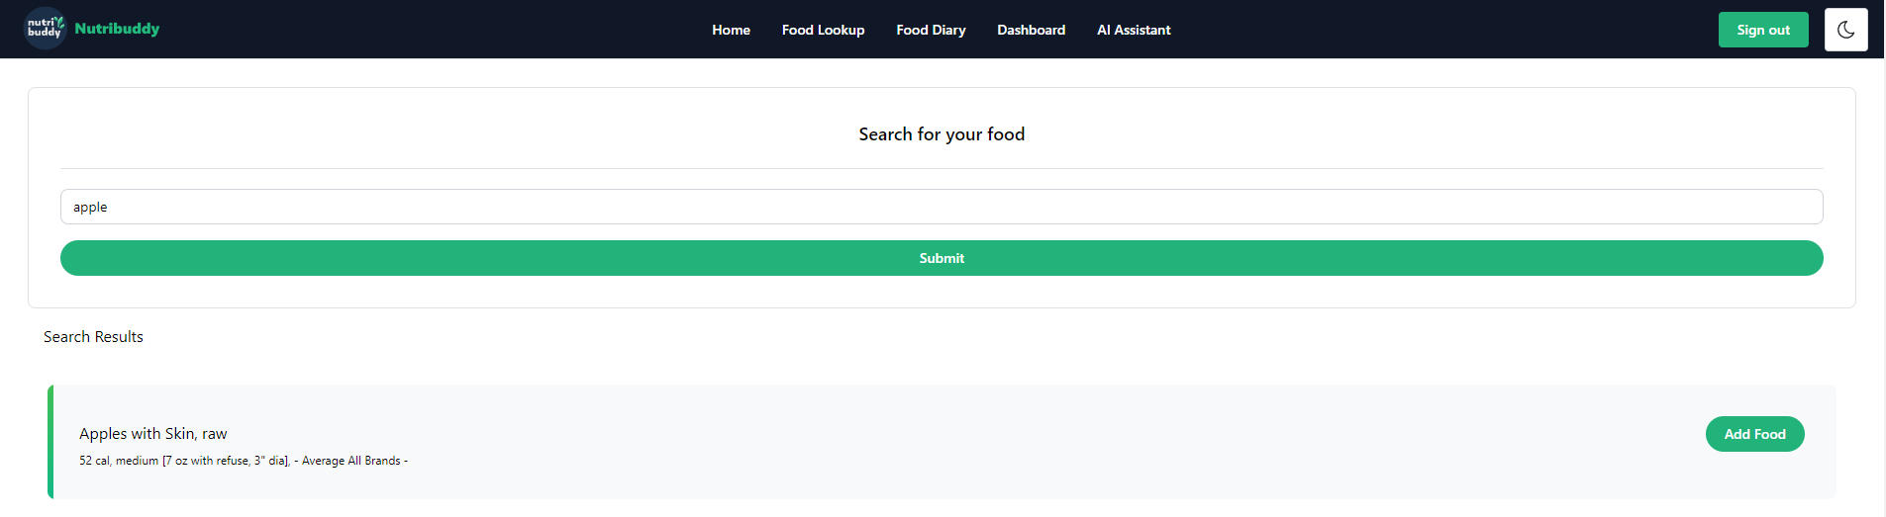

Food can be added to the user’s Food Diary by clicking on the “Add Food” button. Here the serving size and meal at which the food was eaten can be selected to add to the food diary.

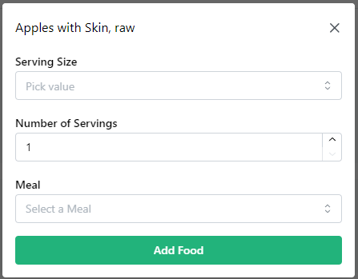

**Dashboard Page**

On the Dashboard the user is prompted with that day’s caloric intake and the remaining calories needed to meet the user’s goals. Here meals can also be logged using the log meals button. When clicking the log meals button the user will be taken to the Food Lookup page where they can add food items to their Food Diary.

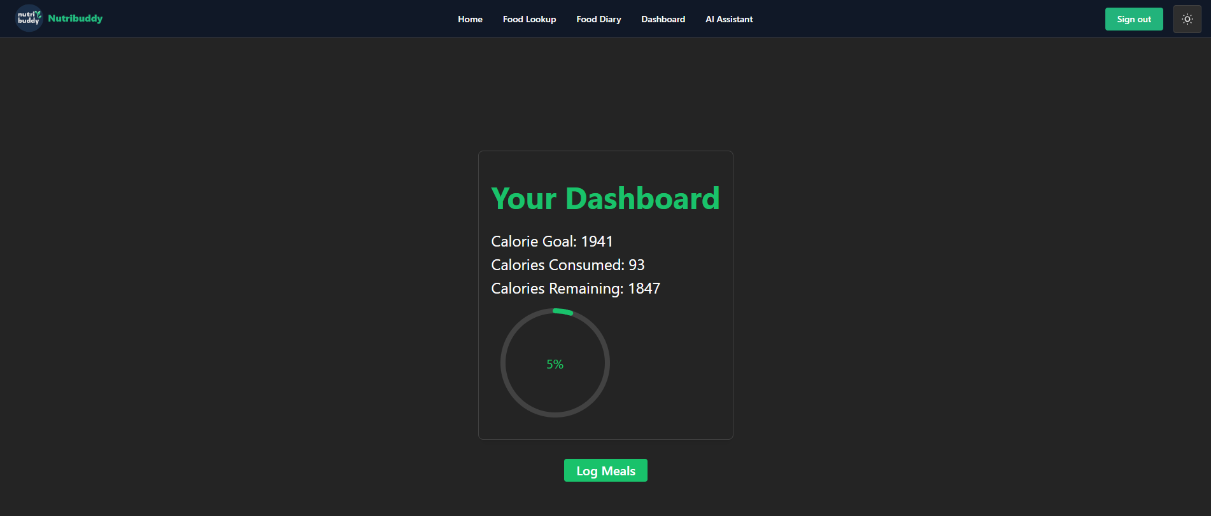

**AI Assistant Page**

On the AI Assistant page the user can interact with a nutritional AI to seek advice to meet their nutritional goals. The user can interact with the AI by typing questions into the text box and hitting the send button at the bottom right.

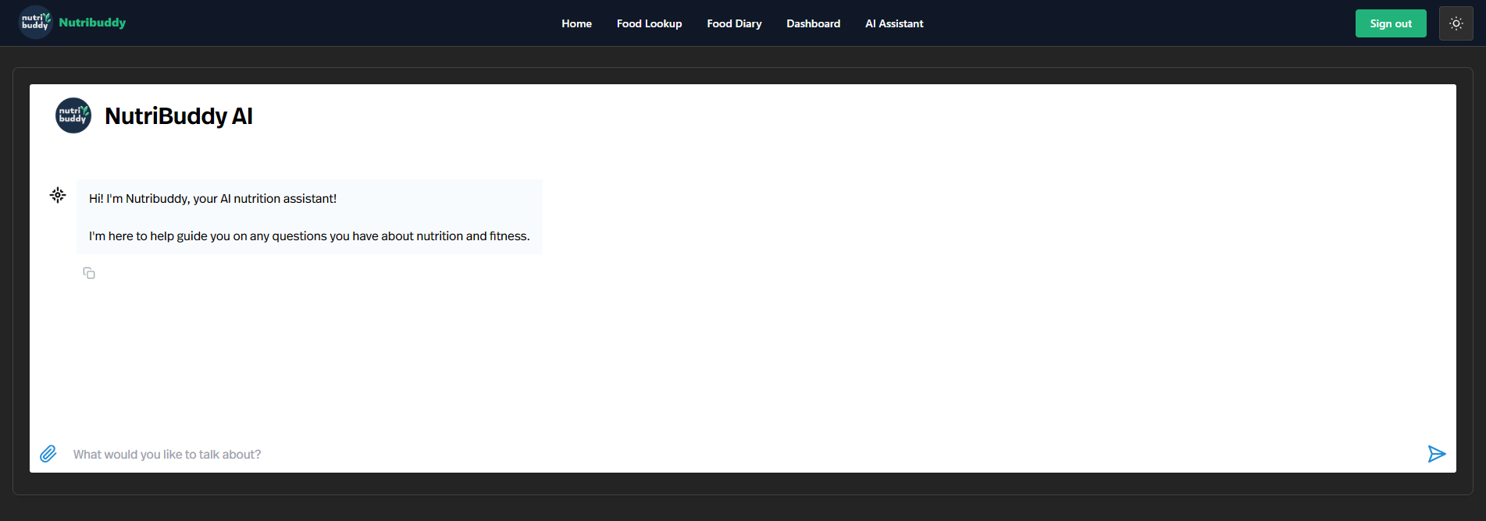

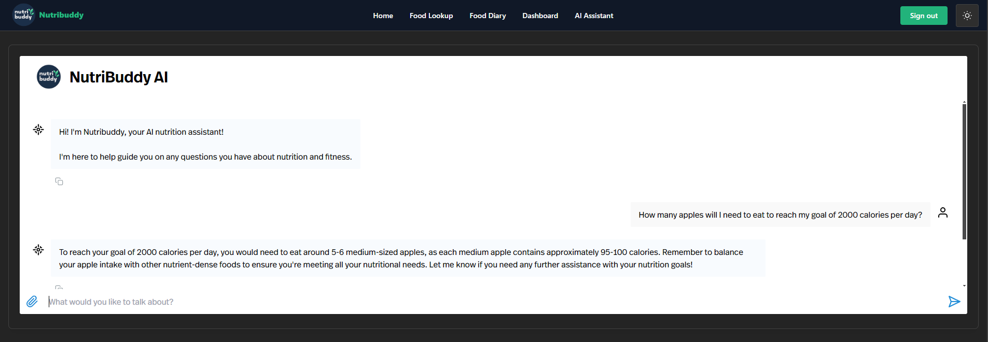

# **Installation Instructions**

Begin the installation of the nutribuddy web application by going to [Github](https://github.com/salvofalcon/capstone-ArgosInc) and cloning the repository or downloading the zip file.

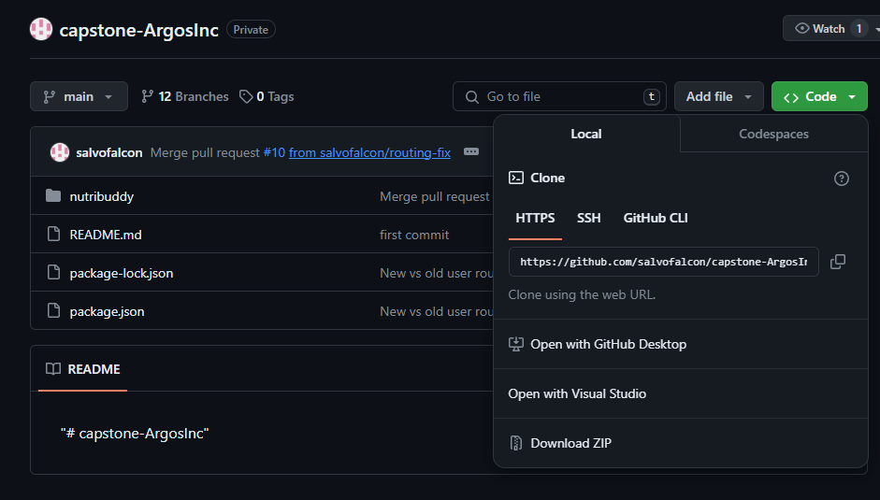

Once the files are downloaded, with command prompt or a similar terminal, navigate to the nutribuddy folder in the terminal and run the “npm install” command, this will install the dependencies needed to run the application.

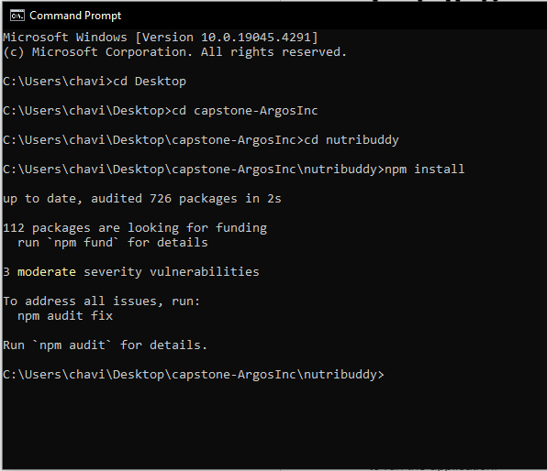

After the “npm install” command is run, a separate terminal will need to be opened. In one terminal navigate from the nutribuddy directory to the backend directory. In this directory run the “npx nodemon app” this will make a connection to the database.

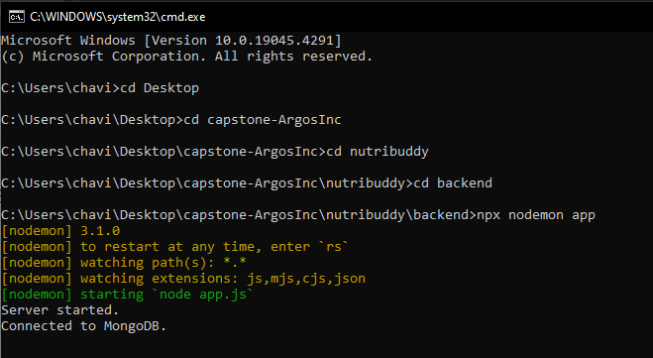

In the original terminal still in the nutribuddy directory, run the “npm run dev” command to start the application. The command will take a second then will give a link to follow to get to the web page.

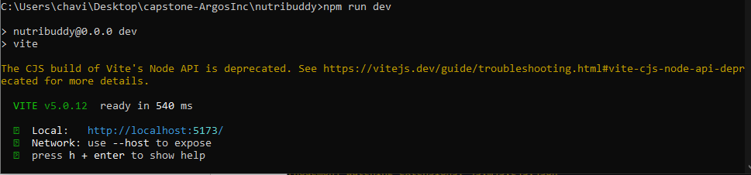

# 

# 

# **FAQ**

**How does NutriBuddy gather nutritional information?**

NutriBuddy uses a free third-party API to pull the nutritional information.

**How does NutriBuddy keep user information safe?**

User health information stored via Nutribuddy is encrypted at the cloud provider level by default. Nutribuddy has the ability to additionally secure this information using a key management solution.

**What is the point of an AI assistant?**

The AI assistant is there to help the user make different healthy decisions when it comes to improving healthy eating. Its creative abilities ensure the users always have a recommendation on new meals.

**Is NutriBuddy a certified nutritionist?**

No, NutriBuddy is there to provide recommendations and advice on meal ideas and recommendations to meet healthy goals, but cannot take the place of a certified nutritionist.

# 

# 

# 

# 

# 

# **Troubleshooting**

**App crashing while trying to run during initial setup.**

If during the setup process, an error similar to the one pictured below, The “npm install” command needs to be run to have the necessary modules installed.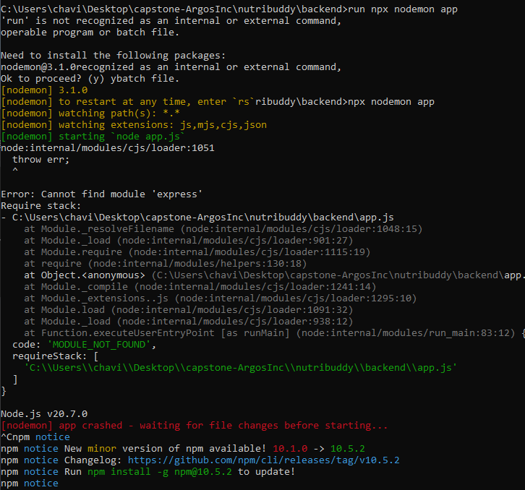

**App crashing during initial setup**

If during the setup process, an error similar to the one pictured below, The “npm i” command needs to be run to have the necessary modules installed.

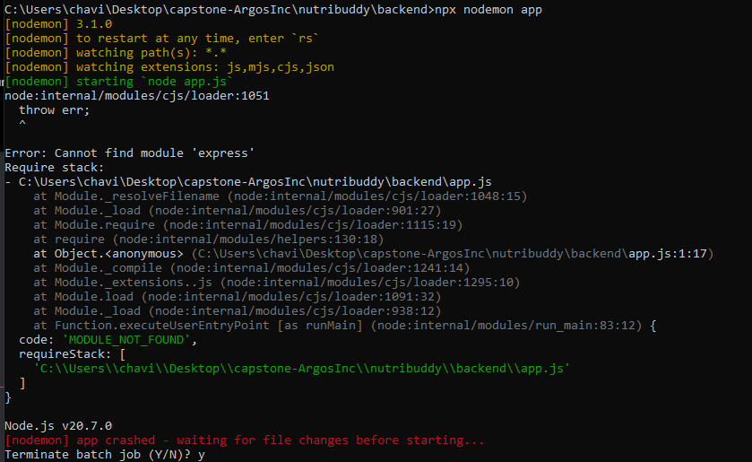

**Stuck on health information page**

If stuck on the BMR calculation page after entering information and clicking the calculate button, simply click the back button in your browser.

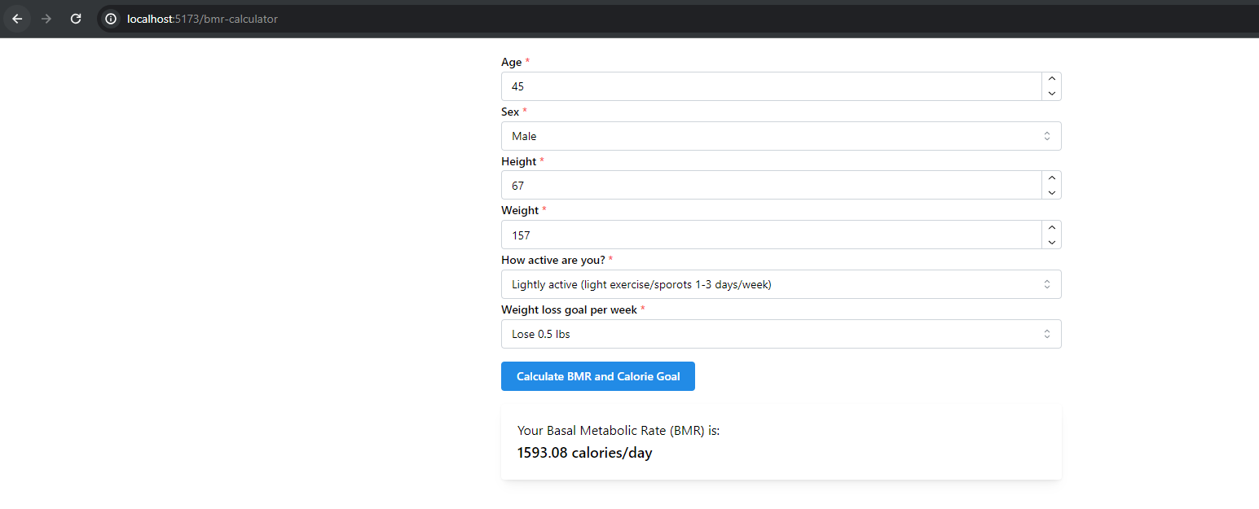

**App not connecting to MongoDB**

If during the setup process, an error similar to the one pictured below, confirm that the .env file is located in the backend folder. If the .env file is not there the repository may need to be re-cloned.

